**Project Development Phase Delivery of Sprint-1**

|  |  |
| --- | --- |
| **Date** | 8 November 2022 |
| **Team ID** | PNT2022TMID0049 |
| **Project Name** | Analytics for hospital’s health care data |

**Project Development Phase**

|  |  |
| --- | --- |
| **Sprint-1:** | **Sprint-3:** |
| ➢ Data Collection ➢ Data Preparation | ➢ Dashboard creation |
| **Sprint-2:** | **Sprint-4:** |
| ➢ Data Exploration | ➢Report Creation ➢ Story Creation |

**Sprint-1:**

**Data Collection:** Download the Dataset Link:

https://drive.google.com/file/d/1slC0MhsJHeuODVkhIXrdNOX_aBDySSBh/view

**Load the Dataset:**

**Tool used:** IBM Cognos Analytic

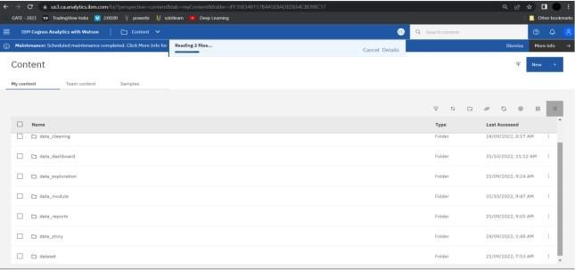

**Data Preparation:**

Prepare the Dataset

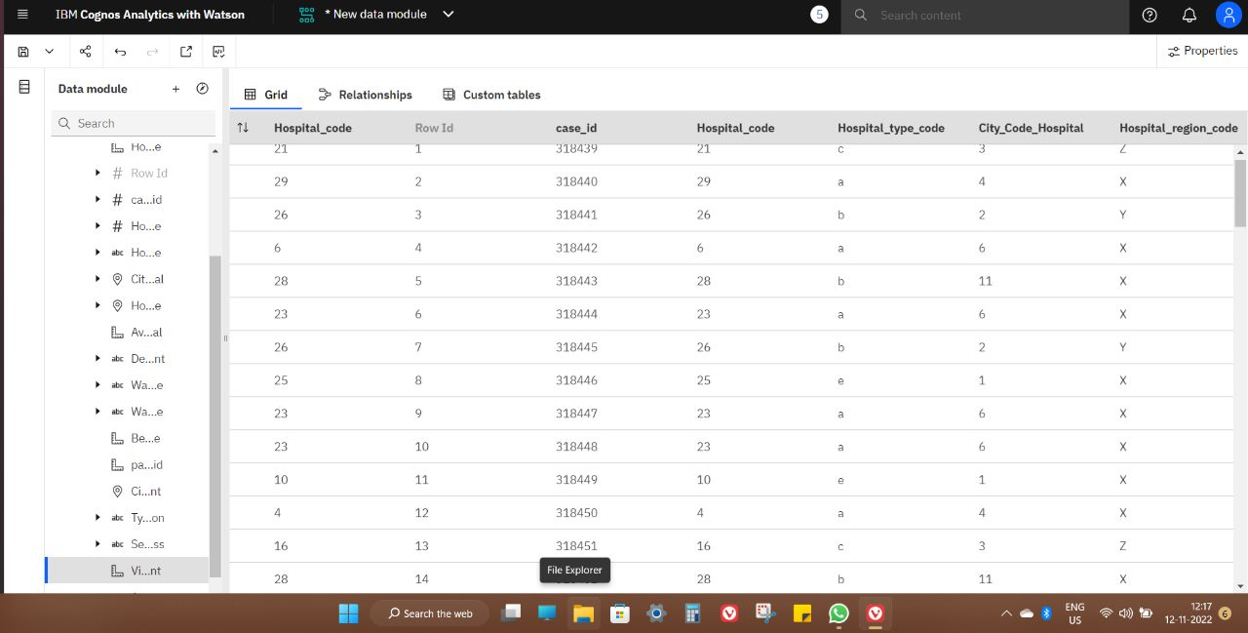

**Null Values Cleaning Process:**

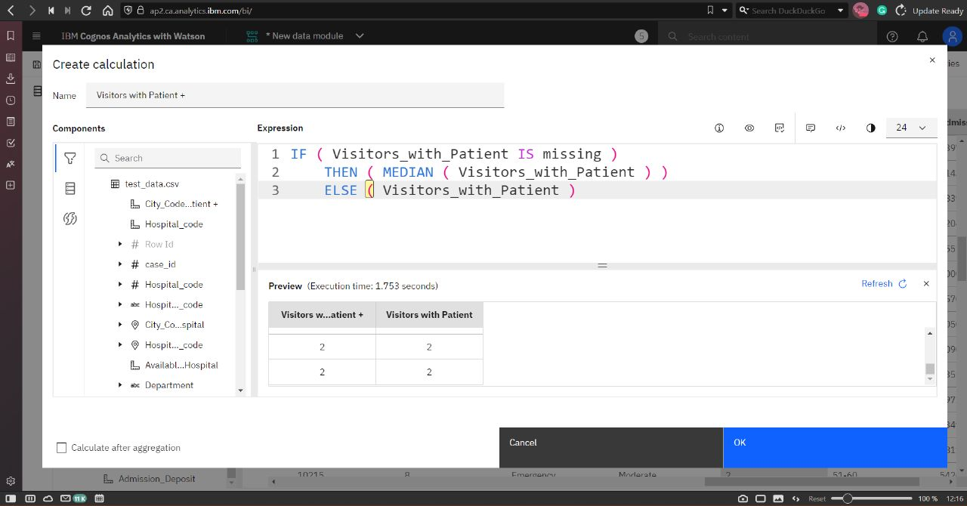

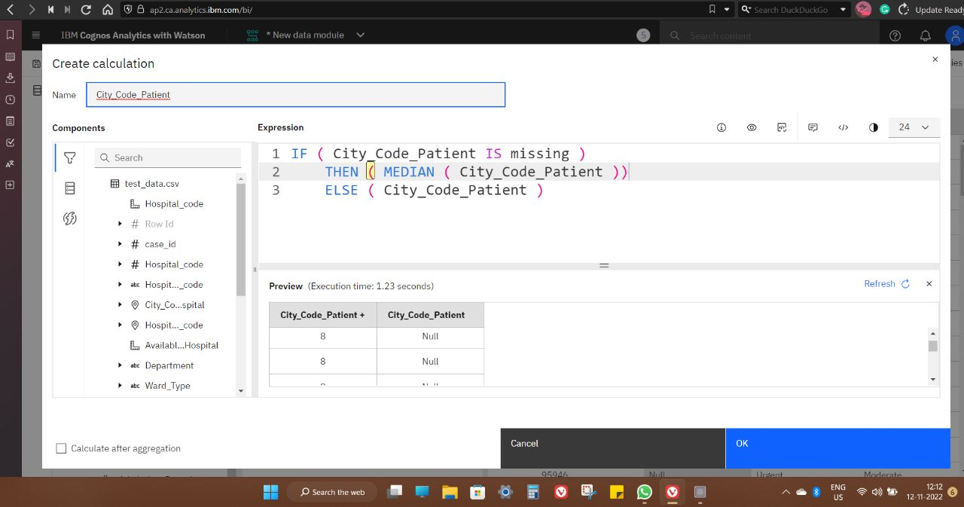

**Hospital Data:**

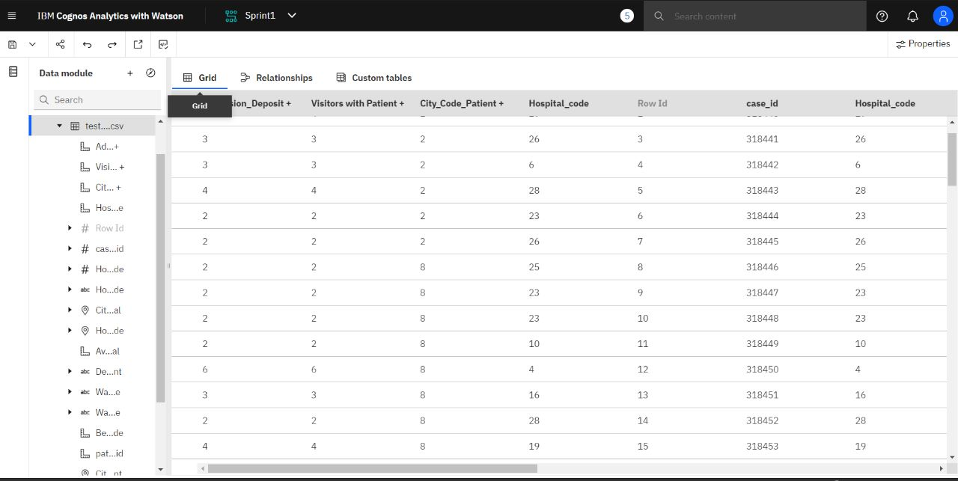

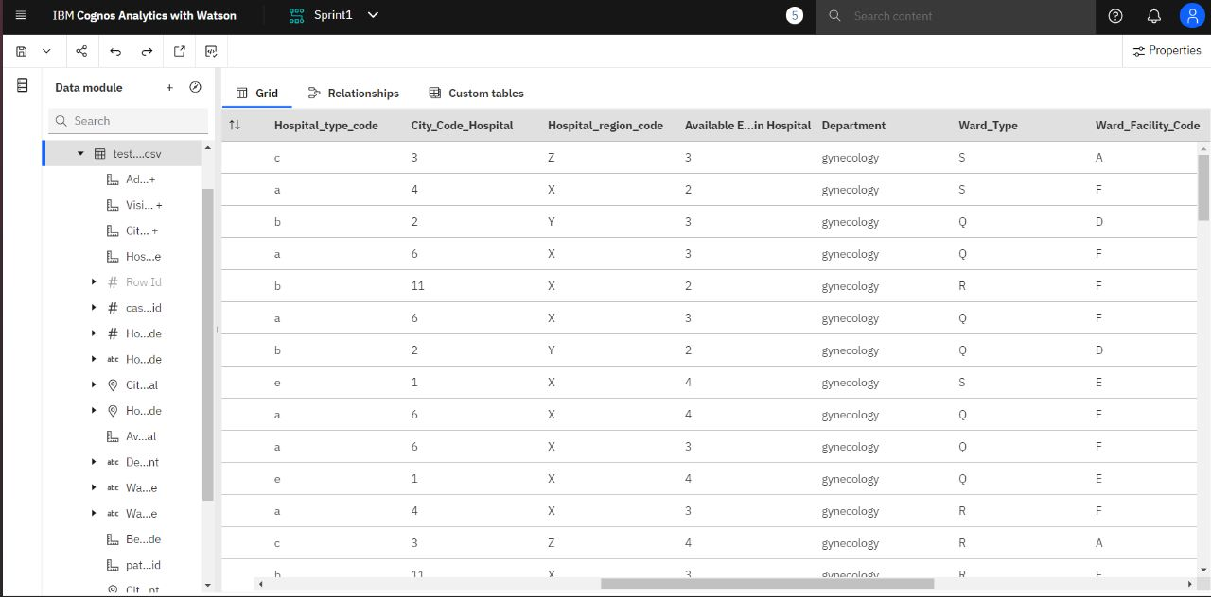

**Prepared data link :**

https://ap2.ca.analytics.ibm.com/bi/?perspective=ca-modeller&id=iCB6DC2DA80B94C6695EABB38C4383360&objRef=iCB6DC2DA80B94C6695EABB38C4383360&tid=1724333042_4b0456d15d4f4de1ab03ac8afaaea773_sessionTemp